**DAS Configuration Using Stratis Utility**

**Theory:**

* **This utility is also used for management of different Hard Drive Partitions.**
* **Here the HDD partitions are been put inside a stratis pool, now inside that pool we convert those HDD partitions into a file system grouply.**
* **This File system is then directly mounted onto mount point for direct access of the storage.**

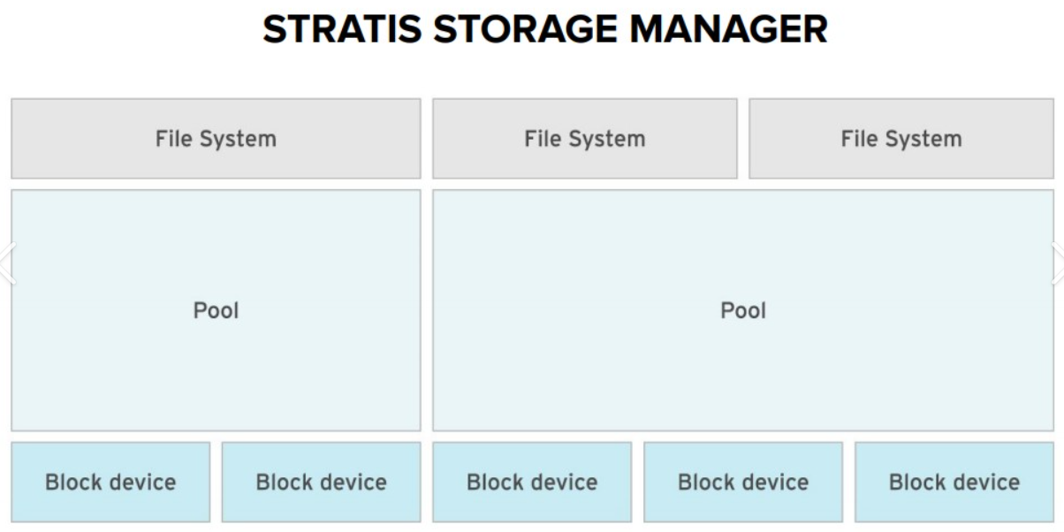

* **List all the stratis packages (stratisd, stratis-cli) & also install them.**

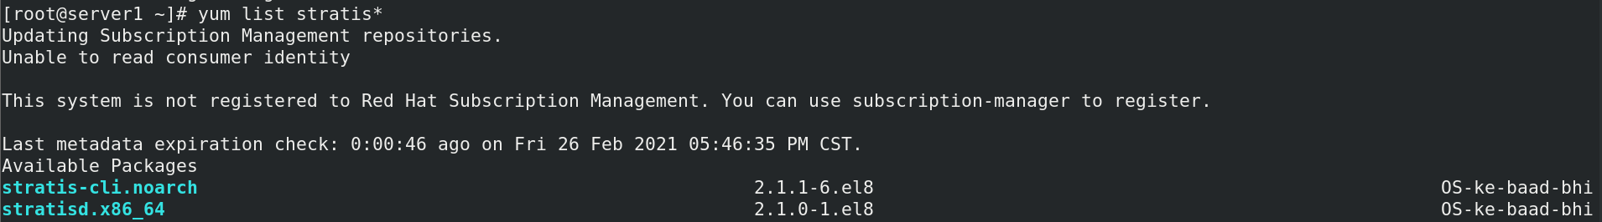

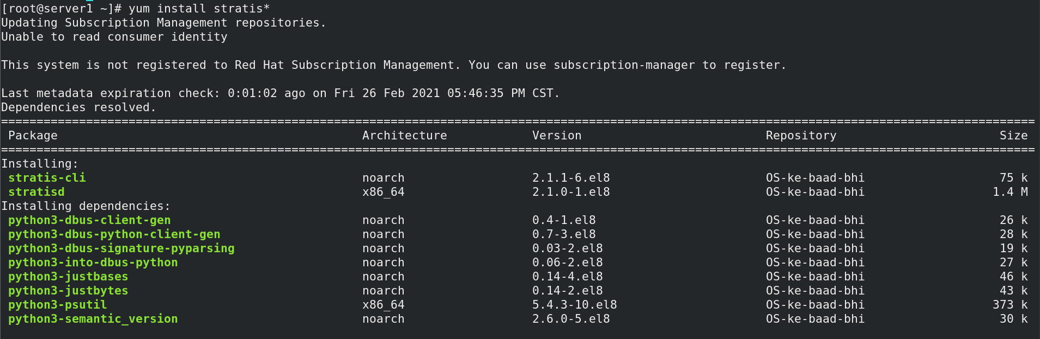

* **Verify If the packages are installed correctly (stratisd, stratis-cli)**

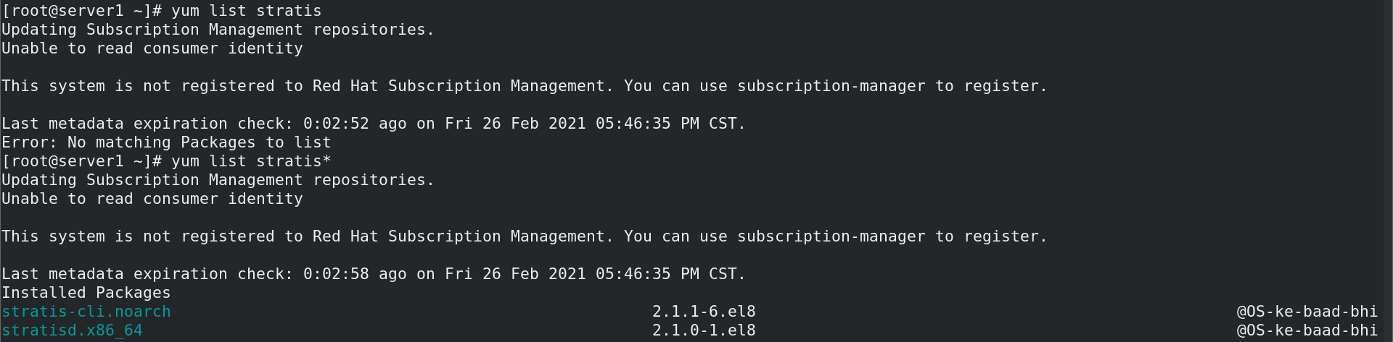

* **Now, Enable the Stratis Utility Service in order to come into action**

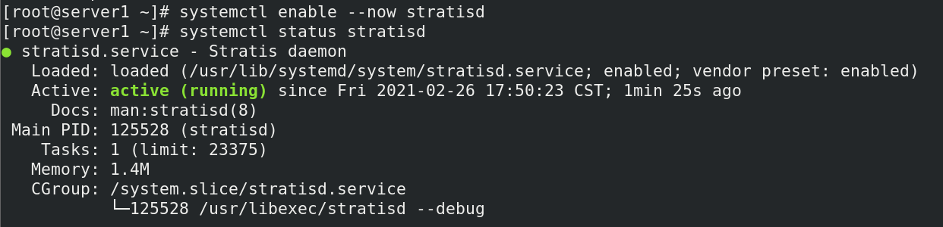

* **Create a Stratis pool called pool1 & add the respective HDDs, also verify the created Statis pool.**

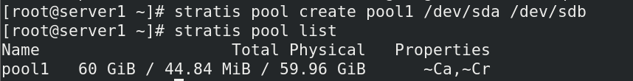

**Stratis pool are not directly used for storage purpose, you first need to convert this pool into Stratis File system.**

* **Convert this Stratis pool into Stratis file system to use it as Storage, also verify the created Statis Files system.**



* **Now to make this as a persistent storage you need to make its entry in /etc/fstab file, so that on reboot this file system will be automatically mounted on to /strat1 directory.**

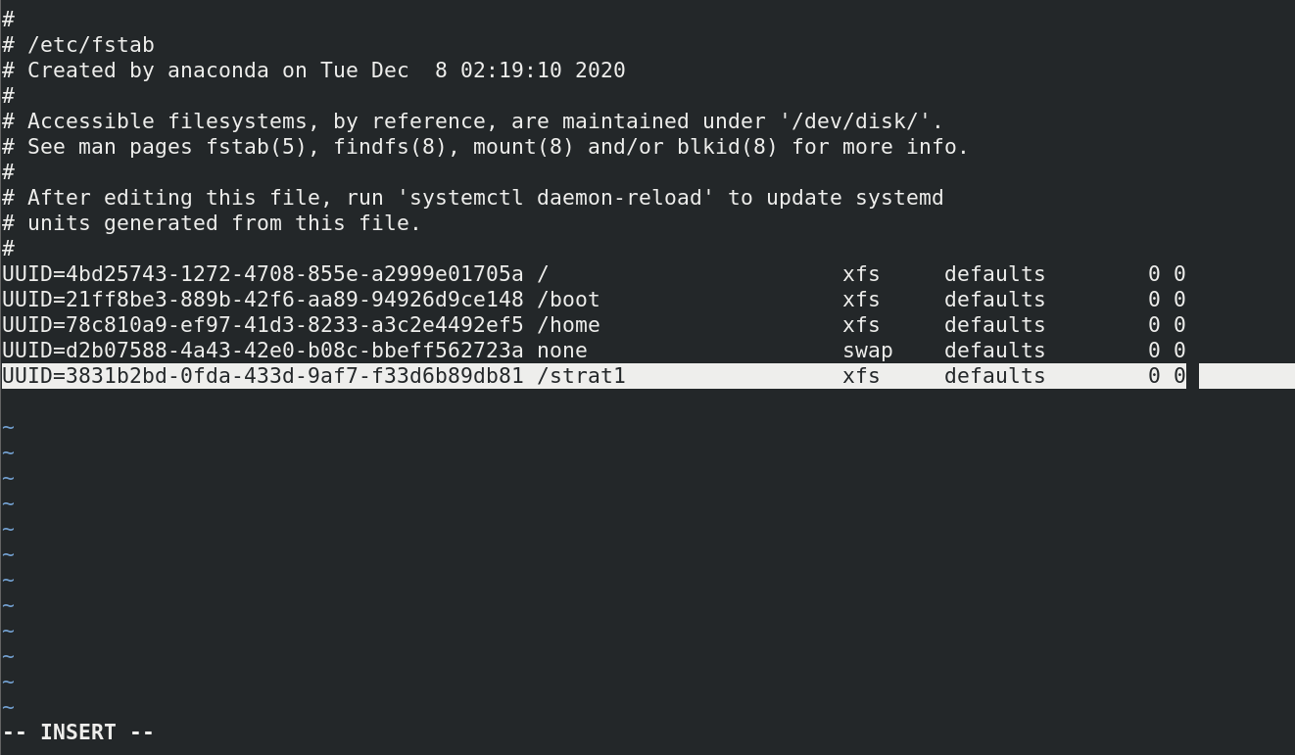

* **Reload the Daemon & again mount all the partition entries in the /etc/fstab file. Also Verify the same.**

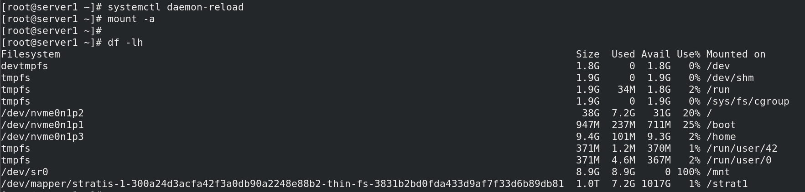

**Now let’s say the HDDs inside the pool are not sufficient for storage purpose, so in this case you can add more HDDs into the same stratis pool**

* **Add one more HDD /dev/nvme0n2 to the same stratis pool.**

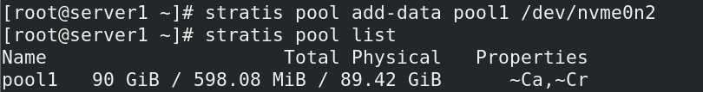

**Taking Snapshots of the FileSystem for Backup**

* **Before taking the snapshot of the file system lets create some data into it.**



* **Take the snapshot of the filesystem (fs1) & also verify the same**



* **Now delete all the data created in /strat1 folder and also unmount the folder.**



* **Create another folder (/strat2) & mount the snapshot file system (fs1s1) onto /strat2 folder. Also verify if you were able to retrieve your previous data from the snapshot file system & provide the screenshot for the same.**

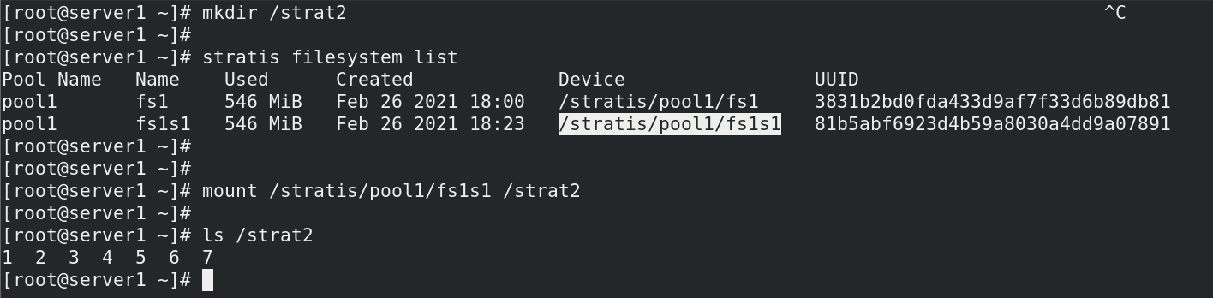

**Destroying the Stratis Pool**

**Note: Once a device (HDD) is added to the pool it cannot be removed (reduced). You can just keep on adding HDD to the Stratis pool but cannot reduce it, but if you want you can destroy the Statis pool.**

* **First unmount the /strat2 folder, then destroy the file system, also the Snapshot file system & then the Stratis pool. Also wipe the data from Hard Drives so that it can be used for some other storage purpose.**

